These tutorials questions should be copied to the C:\RTExamples directory AS IS, i.e q1 directory should be in C:\RTExamples\q1 etc. This will enable them to be built and re-made without any changes to #include paths etc.

To open an example, either start Visual Studio and open a “solution” from the splash screen or navigate to the “.sln” file in the example folder and double click it to bring up the example program in the solution window.

The files rt.cpp and rt.h must also exist in the C:\RTExamples directory and must be included into every Visual C++ project that makes use of RT library and concurrency.

In order to run the programs you must build the whole workspace/solution for each example. To do this right mouse click on the solution name in the solution window and select ‘rebuild solution’. This will build all projects within the solution

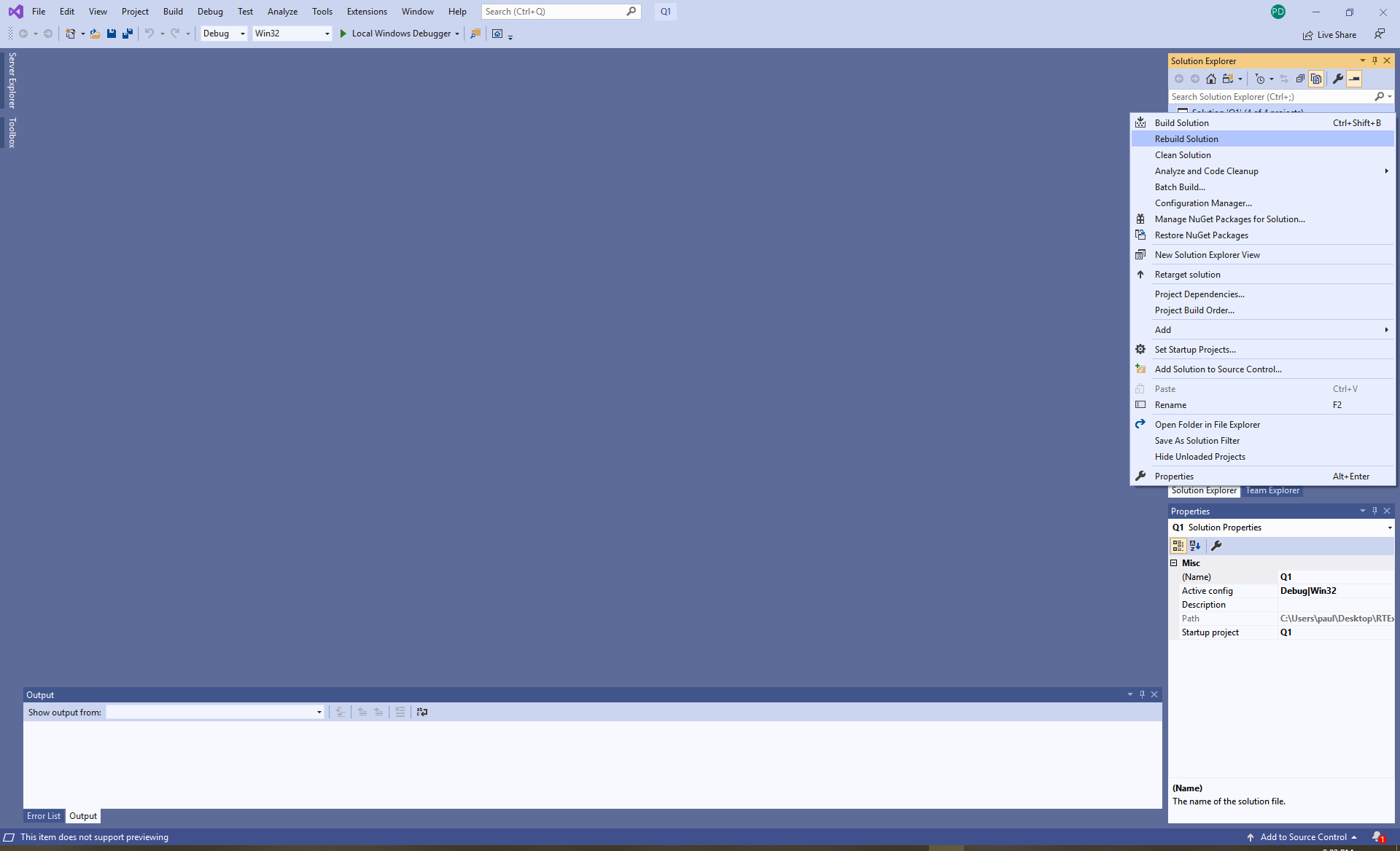

There is a possibility (depending upon what build/service pack of VS 2019 you download) that they might not rebuild as the projects in each solution specify a particular SDK (software development kit) to use. If you get a bunch of errors related to header files, right mouse click on a project in the solution navigator click “properties”, a dialog box will pop as shown below. You can see this on has its SDK set to 10.0, you may not have that installed so another one may have to be selected.
